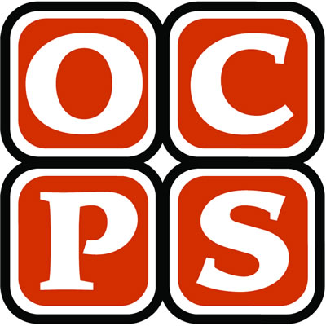

**2015- 2016 Elementary Science Fair Manual**

Learning Community Science Fairs 2016

**Suggested Timeline for Completion**

|  |  |
| --- | --- |
| **KG, 1st, 2nd, 3rd, 4th, and 5th Grades** | |
| **Task(s)** | **Suggested Due Date** |
| * Teacher provides an instructional overview on science fair guidelines and requirements. * Teacher outlines the scientific process and emphasizes that all projects should examine a question with controlled variables. | 4/11/16 |
| * Students choose a topic question/problem to investigate and submit flyer slip for teacher approval. | 4/15/16 |
| * Students research approved question/problem and develop a hypothesis (educated guess). * Students create a citation of at least 2-3 reliable, aligned resources. | 4/19/16 |
| * Students decide on and write a thorough procedure that they will use to test their hypothesis. | 4/21/16 |
| * Students make a list of needed materials. | 4/22/16 |
| * Students gather materials. | 4/24/16 |
| * Students conduct their experiment. * Students collect and record all necessary data. | 5/2/16 |
| * Students organize data and results. * Students write a conclusion based on results. | 5/4/16 |
| * Students write or type a final draft of each project component. | 5/8/16 |
| * Students assemble science fair display board. | 5/10/16 |
| * Students submit project board * Science Projects Displayed during school day * Science Fair @ SLE 5/12/16 from 6-8pm | 5/12/16 |
| * Schools deliver projects to LC science fair between 3:00 – 4:30 pm. * LC Science Fair @ University High School 5/23/16 from 5-7pm | 5/23/16 |

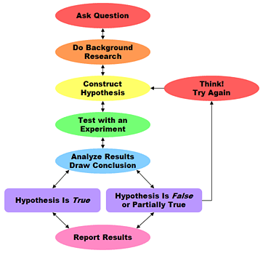

Follow the Science Process

Described in Big Idea 1.

**Choosing a Topic**

Begin by choosing a great topic that interests you. Your topic will be in one of three major categories. Each category will have a subcategory. These are the categories:

**Life Science**

This category deals with animals, plants, humans and the environment. Your question may be about the behavior of these living things. Subcategories include: Animal Behavior, Consumer Science, Plant Activities, Health Science and Ecology. Example projects: Which Paw Does My Cat Prefer? Can Dogs See Color? How Does an Antacid Change the PH level in Juice? Will Dish Detergent Affect Plant Growth? At Which Temperature does Popcorn Pop Best? Can You Tell the Difference in Brand Name or Store Name Cereals?

**Physical Science**

If you like trying to figure out how things work, or are interested in the composition of matter, this category is for you. Subcategories include: Electricity and Magnetism, Chemistry, Physics, Engineering and Mathematics, Sound and Light, Aerodynamics. Example projects could be: Which Battery Lasts the Longest? How Can You Increase the Strength of an Electromagnet? Which Lasts longer and Incandescent Bulb or a Fluorescent Bulb? Which Airplane Design is Best? What Tower Design is the Strongest? How can I Amplify Sound? How Does the Angle of an Object Change the Reflection?

**Earth and Space Science**

This category can be tricky. Subcategories include Weather, Geology, and Astronomy. Sample projects could include: How does Weathering affect our Landscape? Does Road Construction Create Problems With the Habitat in an Area? What Effect Has a Period of Drought had on Lake Lanier? Does A Full Moon Cause Human Behavior Problems? How has the Temperature Affected Our Water Supply? What are the Chances that Georgia will have a Major Earthquake? How does the Weather Impact Travel?

**Come up with a good question.**



**~These are not the only questions you can ask, but be sure to have a quality question that you submit to your teacher for feedback.**



**Conduct research.**

~Research at least three different sources for information. Use the school media center, resources from home or the public library to find encyclopedias, books, models, graphics, other studies or articles about your topic. Ask you teacher for reliable, trustworthy sources so that you can be sure that your information is accurate.

~Identify at least five science vocabulary words, and learn the definition of the words to use in your research paper.

~The research paper should be at least 2-3 paragraphs about your topic. Do not copy and paste information. You need to write notes in your lab book, and then create your research paper.

Make sure to keep a bibliography, which is a list of your sources of information.

**Make a hypothesis.**

A hypothesis is a prediction about your experiment. Display the question you choose in the Hypothesis section of your project display.

~Example Question: Which paper towel is strongest?

~Example Hypothesis: The scientist predicts that **Paper Towel A will be the strongest because it is the thickest, and costs more than Towels B and C.**

*Do not use Brand Names. Label them with a Letter. In the conclusion you can reveal the Brand.*

**Plan your experiment.**

Design an experiment to test your hypothesis. You need to determine your variables, controls, equipment and materials. Remember you need to measure something like time or growth or occurrences and use numbers to record data. You will also need to make observations. Keep the directions clear, and **NUMBER YOUR STEPS.**

**S*ample Project: Strength of Paper Towels***

***First: List your Materials****—Three Brands of Towels, Graduated Cylinder, 500 pennies, testing frame, water, masking tape, empty picture frame, blocks of wood or books, stop watch*

***Second: Write your procedure in numbered steps.***

*1. Prepare a Data Chart.*

*2. Cut three pieces of each kind of paper towel.*

*3. Place one piece of Brand A in a testing frame such as an empty picture frame.*

*4. Tape the towel securely around all edges with masking tape.*

*5. Place frame off the table on blocks that are 3 inches thick or use books to get this off the table.*

*6. Pour 10 mL of water near the center of the towel.*

*7. Wait one minute until water absorbs.*

*8. Place pennies one at a time near the middle until a tear occurs or the pennies fall through.*

*9. Record data and make observations in your logbook.*

*10. Repeat with all of the nine samples.*

***Third: Identify your Variables***

*Independent Variable/Test Variable: What you test - such as kind of paper towel.*

*Dependent Variable/Outcome Variable: What you count - such as number of pennies.*

*Controls: What you keep the same - such as amount of water, and the temperature of the water, size of the towel, distance frame is from tabletop.*

**Carry Out your Investigation**

**Write a Conclusion.**

A conclusion is a summary of what you have learned. It needs to be written in paragraph form. Include answers to the following:

~Was the hypothesis correct, incorrect, or partially correct?

~How does your data prove or disprove your hypothesis? Remember scientists are wrong more than they are right.

~What did the data say? What were the average and the range?

~What observations did you make during the experiment?

~What did you learn from this?

~How would you change this if you did this again?

~Who might use the information that you have found?

~Why is this an important experiment?

~Include any other valuable information that should be communicated to others.

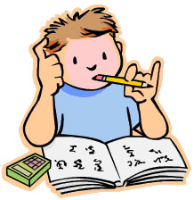

**Design a visual display from your data.**

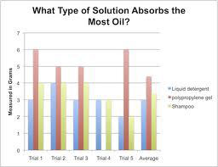

~Use your data table and graph the results. Bar Graphs usually work best.

~Place your Independent Variable on the Horizontal axis (X axis).

~Place your Dependent Variable on the Vertical Axis (Y axis).

~Be sure to title your graph, and use a key if there is more than one color.

~You may make your graph by hand with graph paper, or use the computer to make your graph.

~You may choose to design another type of graphic to communicate your data such as a drawing or photograph of your results.

~You may write a report communicating the data from your investigation. This will not be your conclusion, but a detailed description of the data that you recorded during your experiment. Remember to neatly display your report within your project so that it is easy to read, and be sure that all conventions of print and language are followed.

**Prepare your display.**

Your display must include:

1. Title of Project
2. Question
3. Hypothesis
4. Background Information
5. List of Materials
6. Variables
7. Procedure
8. Data Analysis & Results
9. Conclusion
10. Citation of Resources
11. Bonus Points: Recommendation

Consider the following:

~Adding Photos of Elements of the Investigation (Remember that you need permission to show someone’s face in your work.)

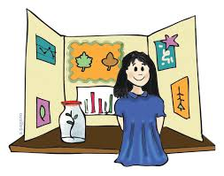

**Hints for Your Board**

~Keep lettering neat and a dark color like black or blue.

~Frame your work with a complimentary color. See your teacher for some paper if needed.

~Lay out your papers before you glue them.

~Use a ruler to keep items straight.

~Type or print very neatly.

~No cross outs, erase neatly.

~No tape should be showing!

~Space your items so that each is easily visible.

~Fill empty space with drawings or clip art, but do not clutter.

~Use a larger font for titles.

~Each section should be titled.

~Follow the sample display format as closely as possible. It makes it easier to read for the judges.

~Yellow is a hard color to read for lettering. Use it sparingly.

~Keep your display simple and attractive.

~Be creative with your title to invite the judge to read it.

~If you use a logbook, place it in front of your board.

**Science Fair Rules**

**1. You may have up to three students per project.**

**2. Kindergarten -2nd grade may submit a class project.**

**3. Adults can help gather materials, supervise the experiment, and help to build the display for all grade levels.**

**4. Judges will judge your project by the information that is shown on your project board based on the rubric within the manual. Remember this is your project, not your parents’. You may ask for help in getting materials and in taking photos.**

**5. The Learning communities will award winners at 3rd, 4th and 5th grade levels.**

**6. The decision of the judges is final and will be based on the *OCPS Rubric found at the end of this packet***

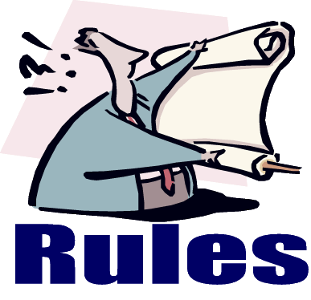

**Safety Rules**

**1. Do not eat or drink during the experiment.**

**2. Wear safety goggles.**

**3. Respect all life forms.**

**4. Any project involving drugs, firearms, or explosives are not permitted.**

**5. Use the internet safely with parent permission and approved sites.**

**6. Sharp tools like knives and electric tools, or chemicals must be supervised and used with adult help.**

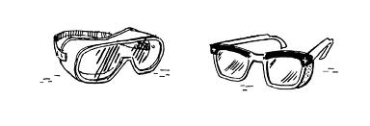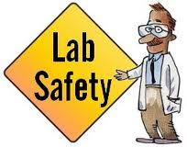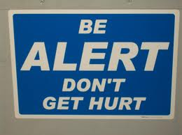

**Helpful Websites**

**Science Fair Central** at **Discovery.com**

http://school.discoveryeducation.com/sciencefaircentral

"Creative investigations into the real world." This site provides a complete guide to science fair projects. Check out

the 'Handbook' which features information from Janice VanCleave, a popular author who provides everything you need to know for success. You can even send her a question about your project.

**Internet Public Library**

http://www.ipl.org/div/kidspace/projectguide/

Are you looking for some help with a science fair project? If so, then you have come to the right place. The IPL will

guide you to a variety of web site resources, leading you through the necessary steps to successfully complete a science experiment.

**Science Fair Idea Exchange**

http://www.halcyon.com/sciclub/cgi-pvt/scifair/guestbook.html

This site has lists of science fair project ideas and a chance to share your ideas with others on the web.

**Cyber-Fair**

http://www.isd77.k12.mn.us/resources/cf/welcome.html

This site has one-sentence explanations of each part of a science fair. One of the steps described is presenting your

project to judges. This may or may not be a part of your science fair. The site also has an explanation of what makes a good project and an explanation of how to come up with your own science fair project.

**Try Science**

http://tryscience.com

Science resource for home that gives you labs to try and 400 helpful links all related to science.

**The Yuckiest Site in the Internet**

http://yucky.kids.discovery.com/

Brought to you by Discovery Kids, this site gives you lots of ideas on how to do the messiest yuckiest experiments.

**Experimental Science Projects: An Introductory**

**Level Guide**

http://www.isd77.k12.mn.us/resources/cf/SciProjIntro.html

An excellent resource for students doing an experiment-based science fair project. There are links on this page to a more advanced guide and an example of an actual experiment-based project.

**Gateway to Educational Materials: Science Fair Projects**

http://members.ozemail.com.au/~macinnis/scifun/projects.htm

The Gateway to Educational Materials extensive and detailed step-by-step guide to doing a science fair project.

**Science Fair Primer**

http://users.rcn.com/tedrowan/primer.html

A site to help students get started and run a science fair project.

**Science Fair Project Guidebook**

http://www.energy.sc.gov/K-12/science_fair.htm

The State of South Carolina publishes a K-12 science fair guidebook. It can be viewed using Adobe Acrobat Reader.

**Science Project Guidelines**

http://www.thesciencefair.com/guidelines.html

The scientists at the Kennedy Space Center have participated in judging local school science fairs for many years and have some great suggestions for student research projects. This information by Elizabeth Stryjewski of the Kennedy Space Center is now provided on a commercial site.

**The Ultimate Science Fair Resource**

http://www.scifair.org/

A variety of resources and advice.

**What Makes A Good Science Fair Project**

http://www.usc.edu/CSSF/Resources/Good_Project.html

A website from USC that gives a lot of good tips and ideas to think about regarding what makes a good science fair

project. Advice for students as well as teachers and parents is included.

**Mr. McLaren's Science Fair Survival Page**

http://www.ri.net/schools/East_Greenwich/Cole/sciencefair.html

Tips from Archie R. Cole Junior High school on what makes a good project.

**Neuroscience for Kids: Successful Science Fair Projects**

http://faculty.washington.edu/chudler/fair.html

Site made by Lynne Bleeker a former science teacher, science fair organizer, and judge. Gives a thorough and detailed

description of the steps to a successful science fair project.

**2016 Science Fair Sample Scoring Rubric**

|  |  |  |
| --- | --- | --- |
| Student: _____________________________________________________ Grade: _______ Teacher: _____________________  Project Title: ______________________________________________________________________________________________ | | |
| **Problem/Question** | | |
| 5 – The student has a well written, testable problem/question that is original and/or related to real-world topics. | 3 – The student has a well written and testable problem/question but doesn’t demonstrate originality or significant real-world context. | 1 – The student’s problem/question is unclear and the question is not testable. The student’s project may only be a scientific model rather than an experiment with controlled conditions. |
| **Hypothesis** | | |
| 5 – The hypothesis is testable and written in a correct format (if-then-because). The hypothesis is original and the student did not already know the answer. | 3 – The hypothesis is present and testable but is not written in the correct format. | 1 – The hypothesis is incomplete and/or not testable. |
| **Background Information** | | |
| 5 – A least 2-3 sources have been researched and aligned to the topic. A summary of the research is included. | 3 – Research is insufficient or not aligned. Research is not summarized. | 1 – The topic was not researched or included in the project. |
| **Materials** | | |
| 5 – All materials are listed with quantities. | 3 – All of the materials are listed but quantities are not included. | 1 – The material list is incomplete. |
| **Variables** | | |
| 5 – The outcome, test, and controlled variables are all identified correctly. | 3 – Not all variables are listed and identified correctly. | 1 – Variables are not included or identified correctly. |
| **Procedure** | | |
| 5 – All steps are clearly written and are easily replicated with at least three trials. | 3 – Not all steps are fully explained or there are less than three trials of evidence. | 1 – Steps are unclear and incomplete. |
| **Data Analysis & Results** | | |
| 5 – Data is clearly labeled showing all three trials and results are explained and linked to data. Correct graph format is used. | 3 – Data and results are not recorded or linked properly. Trials are not identified or labeled. An incorrect graph format was used. | 1 – Data is incorrect; trials are not labeled and not linked to results. |
| **Conclusion** | | |
| 5 – The conclusion fully connects the elements of the purpose, background information, data analysis and results. All questions have been addressed. | 3 – The conclusion does not address all questions. | 1 – Only results have been displaced; there is no evidence of most questions being addressed. |
| **Citation of Resources** | | |
| 5 – At least 2-3 sources have been researched and identified in the project. | 3 – Less than 2 resources have been used or not cited. | 1 – There is no evidence of resources being credited for the student’s research. |
| **Bonus Points** | | |
| 2 – The student provides recommendations related to the project and includes ideas for a redesign. The student proposes new questions for further investigation. | 1 – The student makes an attempt to provide recommendations that are related to the project. The student makes an attempt to describe an opportunity to redesign the experiment. | 0 – No recommendations or ideas for redesign have been made. |
| **Scoring/Comments** | | |
| **Score: ______/47 = _____% Comments:** | | |