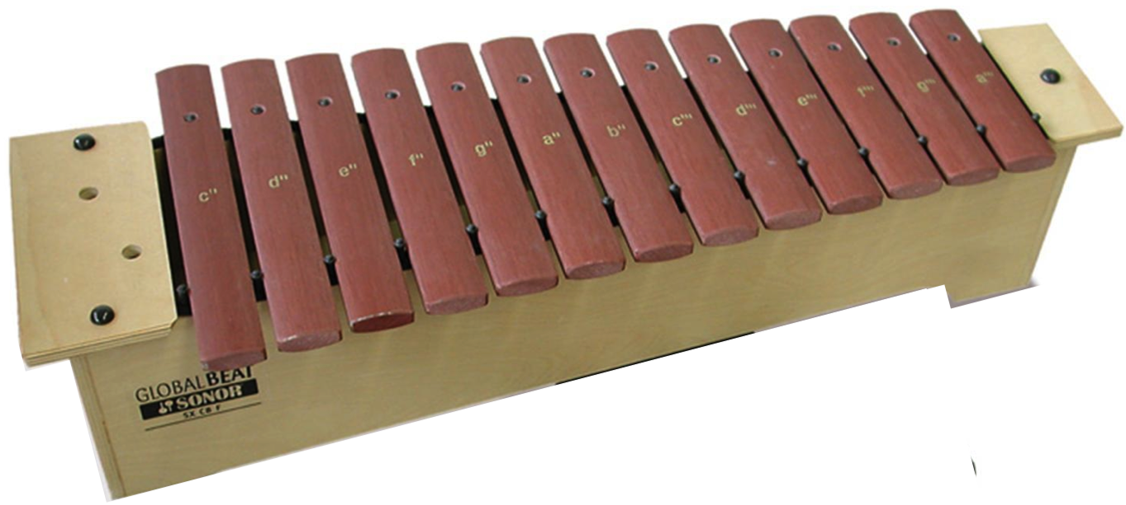
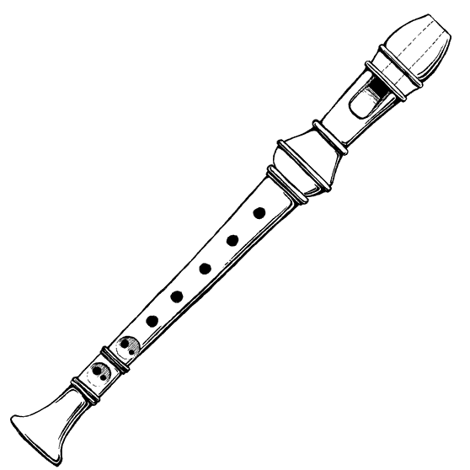
Orff Band Application

You are invited to join the Orff Band. This ensemble makes music using percussion instruments (xylophones, drums, etc) and recorder. Rehearsals are every Tuesday after school, from 3:00 – 4:15, beginning October 3. Joining Orff Band means you commit to attending all rehearsals and the concert. Students must purchase a performance shirt for $6. (This is the same shirt chorus will wear, so if in both ensembles, you only need to purchase one shirt.)

Concert:
December 12, 6:30pm. Dommerich Cafeteria Stage

Questions? Contact Mrs. Krulick at cynthia.krulick@ocps.net or
407-623-1407, ext 3254237
Web page: teacherpress.ocps.net/cynthiakrulick/

  Yes! I would like to join Orff Band. I will always listen carefully, work hard and give my personal best! I understand that if I miss two or more rehearsals I may not be able to participate in the concert.

Student Signature ___________________________________

Classroom Teacher__________________________________

My child has permission to join the Orff Band and stay after school on Tuesdays
❑ I will pick them up at 4:15 in front of the school (Thistle Lane) in the car line.
  My child has permission to walk or ride their bike home.
  My child is in YMCA aftercare.

Parent Signature _____________________________________________

Phone 1 _________________________Phone 2 ____________________

Email ______________________________________________________

To receive text messages with Dommerich Band updates sign up at remind.com/join/dommeric

Applications due Friday, September 29. Rehearsals begin October 3.

