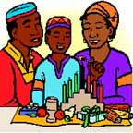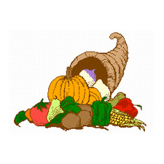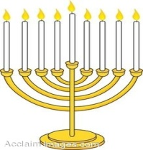

Dear Parents,
In Social Studies we will be learning about how people celebrate their culture, history and national holidays. The students will, as part of our studies, do a project about a tradition their family celebrates.
This is a wonderful opportunity for your family to talk about a tradition that you celebrate and for your child to learn more about that tradition. It is also a great opportunity for the students in the class to learn about traditions they might not know much about.
Please help your child choose a tradition your family celebrates and brainstorm ideas and research information to include. You may create a poster or a powerpoint. You may also send in small treats or tokens that are associated with your project to share with the class. The project is due Thursday, November 6th.

Thank you for your help,
Mrs. Whelan

“Celebrating Traditions”
Project Rubric
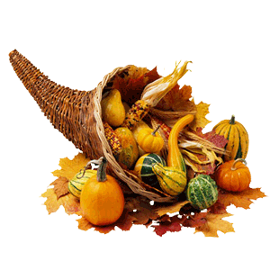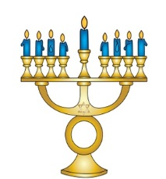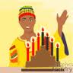

Name: ________________ My Family Tradition: ______________________

Required information  (Please be specific and include details) | Points
When do you celebrate this tradition? (Time of year or specific date) | 3
Where do you celebrate this tradition? (Home, church, temple, etc.) | 3
Who do you celebrate this tradition with? (Family, friends, etc.) | 3
What person or event do you celebrate? (Name of person or holiday) | 7
Why do you celebrate this person or event? (Explanation of event or person) | 8
How do you celebrate your family tradition? (Having a feast, dressing up, exchanging presents, watching fireworks, etc.) | 8
What are two symbols used during this celebration?  What do these symbols represent? | 8
Make sure your writing is neat and the words spelled correctly. Use complete sentences. | 5
Give a five minute presentation. Speak clearly and share all information. | 5
Total points: / 50 Percent: Grade:

