School Book New Regular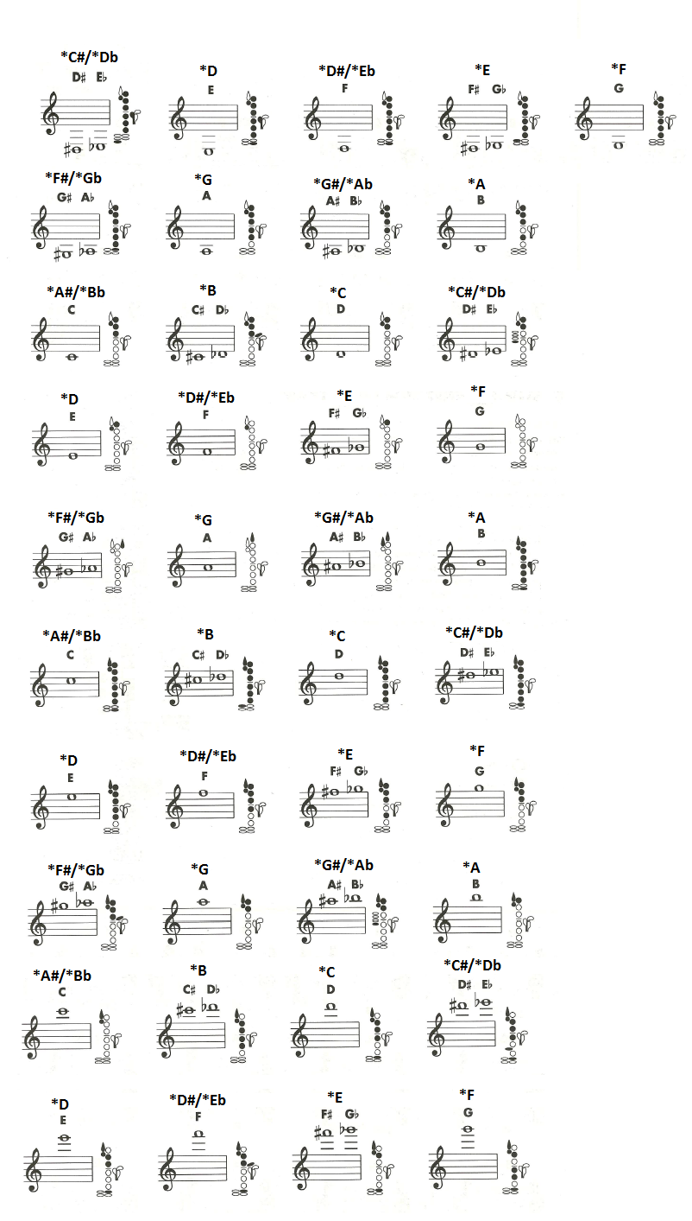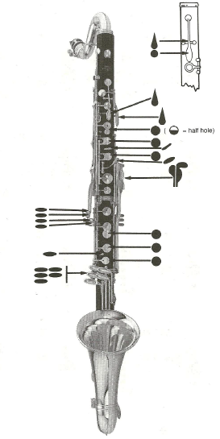

**Your Instrument’s Key**

Your instrument is built in the key of Bb. This means you are like the Clarinet, Trumpet, & Tenor Saxophone. To use a tuner you need to have Bb listed at the top.

**Concert Names**

Since you are in the key of Bb you have to know Concert names (*= Concert for Miss Jaques). For example: *Bb=C or *F=G.

**\*D**

**\*D**

Name (F&L):_____________________________________

Period: ________

**Symbols**

**Colored in circles/shapes (colored black)** = push and hold them down

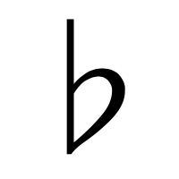= flat

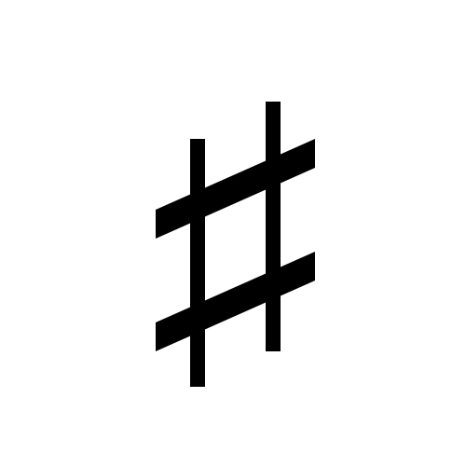= sharp

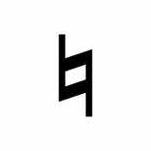= natural (just regular letter)