School Book New Regular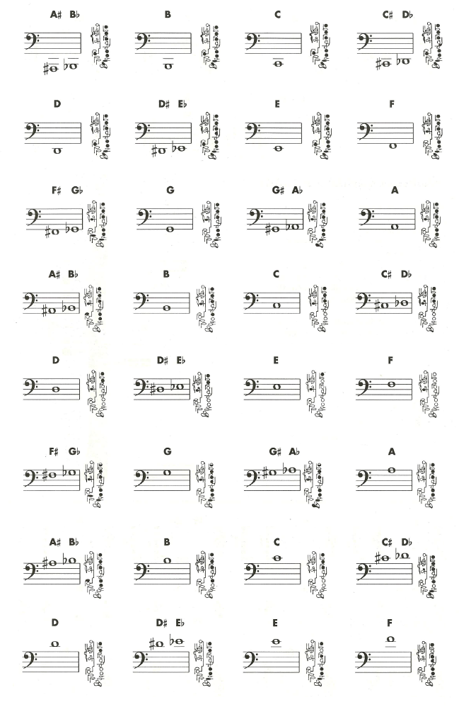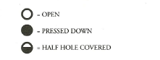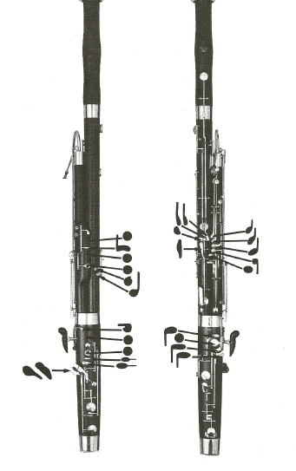

Name (F&L):_____________________________________

Period: ________

**Concert Names**

Since you are in the key of C when Miss Jaques says Concert or writes * (*=Concert for Miss Jaques) you just go to the regular letter. For example: *C=C or *Gb=Gb.

**Symbols**

**Colored in circles/shapes (colored black)** = push and hold them down

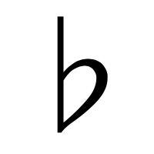= flat

= sharp

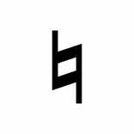= natural (just regular letter)

**Your Instrument’s Key**

Your instrument is built in the key of C. This means you are just like the Human Voice, Piano, Trombone, Euphonium, and Tuba. To use a tuner you do not need to have any letter listed at the top because it automatically is in C.