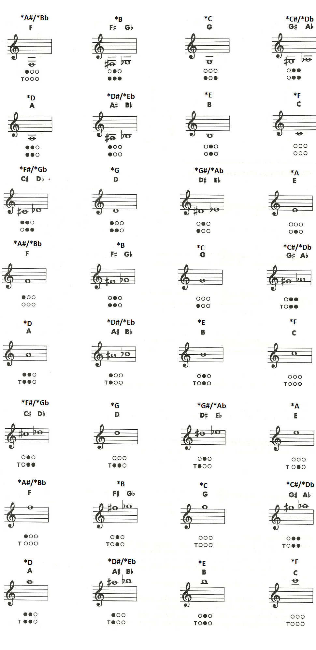School Book New Regular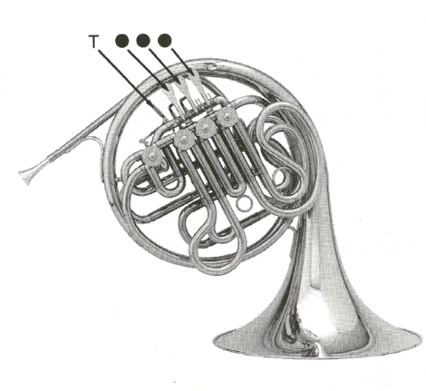

**SINGLE HORN:** Top Fingerings

**DOUBLE HORN:** Bottom Fingerings

**Your Instrument’s Key**

Your instrument is built in the key of F. To use a tuner you need to have F listed at the top.

**Concert Names**

Since you are in the key of F you have to know Concert names (*= Concert for Miss Jaques). For example: *Bb=F or *F=C.

**Symbols**

**Colored in circles/shapes (colored black)** = push and hold them down

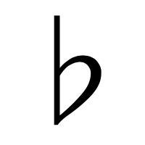= flat

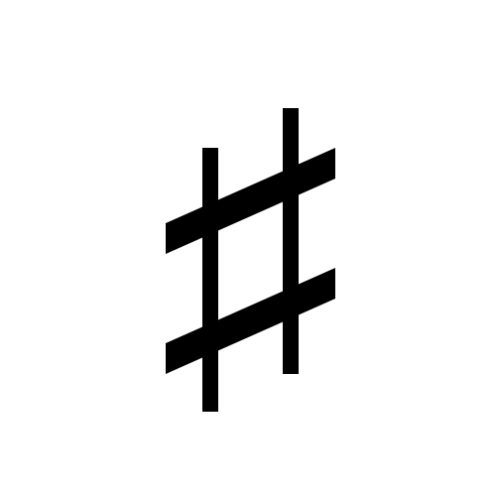= sharp

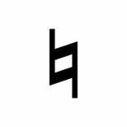= natural (just regular letter)

The first circle is the one closest to your mouth.

Name (F&L):_____________________________________

Period: ________