Red Rainbow Math Facts Set 1
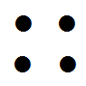

 | 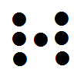
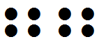

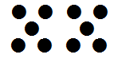 | 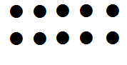
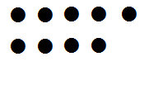 | 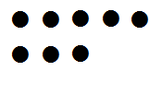
Red Rainbow Math Facts Set 2
0  zero | 1  one
2  two | 3  three
4  four | 5  five
6  six | 7  seven
8  eight | 9  nine
Orange Rainbow Math Facts Set 1
10  ten | 11  eleven
12  twelve | 13  thirteen
14  fourteen | 15  fifteen
16  sixteen | 17  seventeen
18  eighteen | 19  nineteen
20  twenty | 21  twenty-one

Orange Rainbow Math Facts Set 2
22  twenty-two | 23  twenty-three
24  twenty-four | 25  twenty-five
26  twenty-six | 27  twenty-seven
28  twenty-eight | 29  twenty-nine
30
thirty
 | 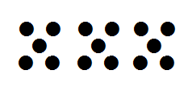
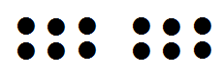 | 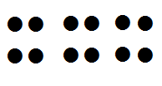

Yellow Rainbow Math Facts Set 1
0+1= 1 | 1+0= 1
0+2= 2 | 2+0= 2
0+3= 3 | 3+0= 3
0+4= 4 | 4+0= 4
0+5= 5 | 5+0= 5
0+6= 6 | 6+0= 6
0+7= 7 | 7+0= 7
0+8= 8 | 8+0= 8
0+9= 9 | 9+0= 9

Yellow Rainbow Math Facts Set 2
1+1=2 | 1+2=3
2+1=3 | 1+3=4
3+1=4 | 1+4=5
4+1=5 | 1+5=6
5+1=6 | 1+6=7
6+1=7 | 1+7=8
7+1=8 | 1+8=9
8+1=9 | 1+9=10
9+1=10 | 1+10=11

Green Rainbow Math Facts Set 1
2+2= 4 | 2+3= 5
3+2= 5 | 2+4= 6
4+2= 6 | 2+5= 7
5+2= 7 | 2+6= 8
6+2= 8 | 2+7= 9
7+2= 9 | 2+8= 10
8+2= 10 | 2+9= 11
9+2= 11 | 2+10= 12
10+2=12 | 2+11=13

Green Rainbow Math Facts Set 2
3+3= 6 | 3+4= 7
4+3= 7 | 3+5= 8
5+3= 8 | 3+6=9
6+3= 9 | 3+7=10
7+3= 10 | 3+8=11
8+3= 11 | 3+9=12
9+3=12 | 3+10=13
4+4=8 | 4+5= 9
5+4=9 | 4+6=10

Blue Rainbow Math Facts Set 1
6+4=10 | 4+7=11
7+4=11 | 4+8=12
8+4=12 | 4+9=13
9+4=13 | 4+10=14
10+4=14 | 4+11=15
5+5=10 | 5+6=11
6+5=11 | 5+7=12
7+5=12 | 5+8=13
8+5=13 | 5+9=14

Blue Rainbow Math Facts Set 2
9+5=14 | 5+10=15
10+5=15 | 6+6=12
7+6=13 | 6+7=13
8+6=14 | 6+8=14
9+6=15 | 6+9=15
10+6=16 | 6+10=16
7+7=14 | 7+8=15
8+7=15 | 7+9=16
9+7=16 | 7+10=17

Indigo Rainbow Math Facts Set 1
10+7=17 | 8+8=16
8+9=17 | 9+8=17
8+10=18 | 10+8=18
9+9=18 | 9+10=19
10+9=19 | 10+10=20
2-1=1 | 3-1=2
4-1=3 | 5-1=4
6-1=5 | 7-1=6

Indigo Rainbow Math Facts Set 2
8-1=7 | 9-1=8
10-1=9 | 2-2=0
3-2=1 | 4-2=2
5-2=3 | 6-2=4
7-2=5 | 8-2=6
9-2=7 | 10-2=8
3-3=0 | 4-3=1
5-3=2 | 6-3=3
7-3=4 | 8-3=5

Violet Rainbow Sight Words Set 1
9-3=6 | 10-3=7
4-4=0 | 5-4=1
6-4=2 | 7-4=3
8-4=4 | 9-4=5
10-4=6 | 10-5=5
5-5=0 | 7-5=2
6-5=1 | 9-5=4
8-5=3 | 7-6=1
6-6=0 | 8-6=2

Violet Rainbow Sight Words Set 2
9-6=3 | 10-6=4
7-7=0 | 8-7=1
9-7=2 | 10-7=3
8-8=0 | 9-8=1
10-8=2 | 9-9=0
10-9=1

