Gargoyles and Grotesques
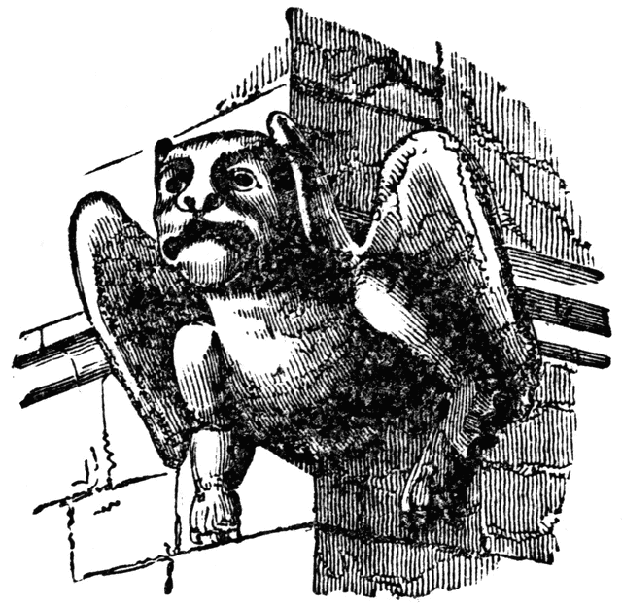
- La Gargouille, was a legendary dragon that lived in the River Seine, which in the 7th Century was ravaging the town and people of Rouen. It was slain by St Romanus, the Archbishop of Rouen. After the dragon was slain its body was set ablaze, its body was consumed by fire but the head and neck survived and was mounted on a building.
- Technically an architect calls a waterspout on a building a gargoyle. If a stone carving does not carry water and has a face that resembles a creature, it is technically called a grotesque. A strange beast which combines several different animals is called a chimera.
- shares a common root with the word "Gargle"; which comes from "gargouille", an French word for "Throat“
- The word “gargoyle” is also a derivative from the Latin word, “gurgulio”, which had a double meaning, “throat”, and the “gurgling” sound water makes as it passes through a gargoyle.
Notre Dame
- What do you see when you look up to the top of the great cathedral of Notre Dame? You see monsters, half-man and half-beast. These demon looking creatures carved out of stone are called gargoyles. They are one of the many eerie stone figures that adorn the gutters of the Cathedral of Notre Dame in Paris. Gargoyle comes from a Latin word, meaning gullet or drain. That's what the strange looking creatures are, they're drainpipes. Each grotesque figure has a passageway inside that carries rainwater from the roof and out through the gargoyle's mouth. From the top of the cathedral's towers the gargoyles have a magnificent view of the city.
- The cathedral also served as a "sermon in stone" which could be "read" by an illiterate population. Some gargoyles clearly fill this instructional purpose by illustrating Bible stories such as Eve's reach for the apple and frightening images of eternal torment. Since gargoyles were on the outside of the cathedral and scenes of the Bible and statues of Jesus, Mary and the Saints where common inside the building, this represented God's power to protect the believers. They also represented the struggle between good and evil and symbolized how God was the only protection from evil in a fallen world.
- Gargoyles stand guard, warding off unwanted spirits and other creatures and If they're hideous and frightening enough, it was thought they would be especially effective in scaring off all sorts of other threatening creatures. Perhaps it was en believed that some came alive at night protecting people when they were most vulnerable. Better still, the ones with wings could fly and protect the village as well as the church.
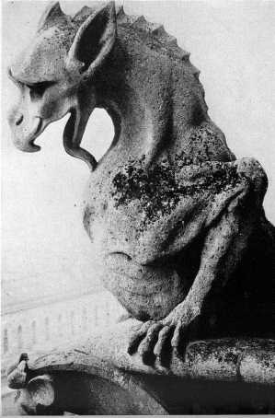
chimeras
- Gargoyles crafted during Medieval times became increasingly grotesque in design. Soon they were referred to as “chimeras” because of their representations of creatures that were not of this world - half man, and half bird or beast.
- These new incarnations were either depicted sitting on their haunches or poised to take flight. They also possessed over exaggerated muzzles or beaks and other odd appendages. They were positioned on a cornice molding so they projected forward and away from the building for a number of feet. In this way the gargoyle was able to spew water far from the building.
- "Although the demons and monsters so prevalent in cathedral sculpture may seem almost quaint to modern eyes, the men of the Middle Ages did not find them so. In a time when illiteracy was almost a universal condition and belief in a literal, waiting Inferno prevailed, the purpose of most cathedral sculpture was not decorative but instructional. It was intended, to scare its beholders, and there is every reason to believe it did a creditable job, presenting the horrors of torment in living color (of which only faint traces remain today)."

