A departure in Italian painting took place in the 13th century because of ______________________________________________________.
Until then the mass had been celebrated with the priest ______________, facing the people (as it is done now) then the priests' position was changed so that he faced the altar form the ____________.
This freed the space behind the and above the altar for ______________ on wood panels. Like the manuscript illuminations, these works were painted with ______________________.

Giotto (1267-1337)
- How he was he discovered?

- Who discovered him?

- Who was Cimabue?

- What makes his painting innovative?

- Why were later Roman Artists not interested in painting realistically?

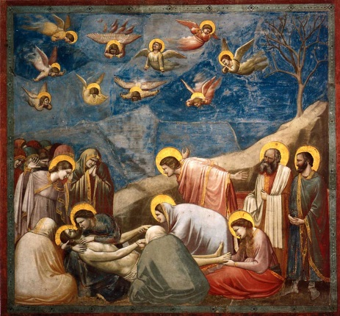

- Where is it?

- What does it illustrate? What is the painting about?

- What makes it special?

Artist:
Title:
Date:

Duccio (1278-1319)
- What commission made him famous?

- How long did it take him?

- What happened when he finished?

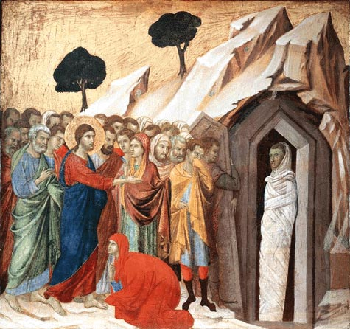
Artist:
Title:
Date:

- Where is it?

- What does it illustrate? What is the painting about?

- What makes it special?

Simone Martini 1284-1344

Who was his teacher?
Who did he work for?
Who did he pick up some ideas, techniques and style from?
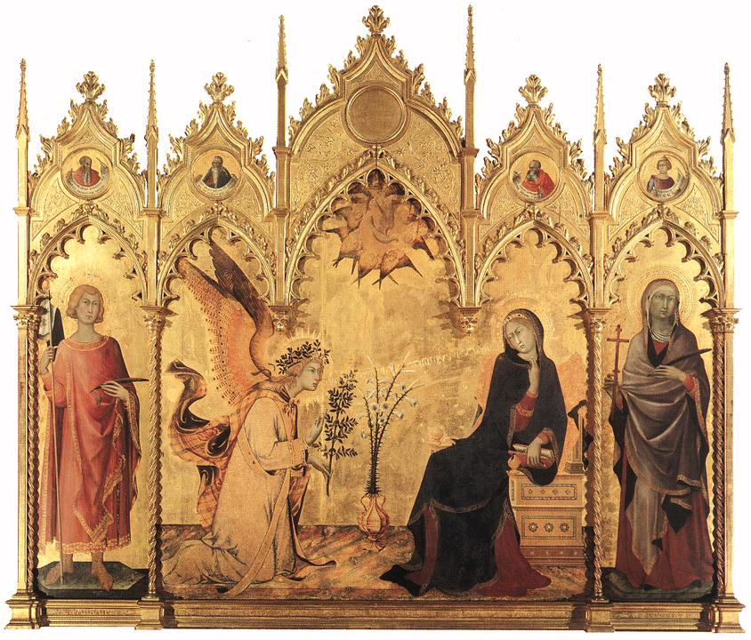

Artist:
Title:
Date:

- Where is it?

- What does it illustrate? What is the painting about?

- What makes it special?

