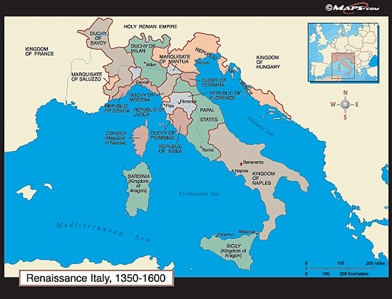
The Early Italian Renaissance
Renaissance means ___________. In the early 1400s, a cultural rebirth created a period of intense artistic activity throughout Europe that would last for 200 years. Leaders in this artistic flowering lived in the city of ___________.
Florence was dominated by the ____________, a powerful family who were great _________________________________________.
The Florentine artists, fueled by a renewed interest in the ancient _____________________________ as well as in ______________________, created a city of extraordinary beauty. Though magnificent sculpture and architecture were produced, _________________ dominated the art of the Renaissance.
Fillippo Brunelleschi 1377-1446
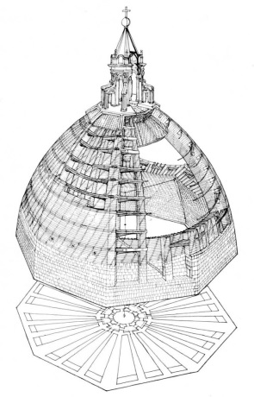
- What jobs was he famous for?
- What was his greatest architectural achievement?
- Besides an architect, what else was Brunelleschi?
- What is scientific perspective?
- What happened in 1418?
- Why did he go to Rome?
Dome for the Cathedral of Florence
1420-1436

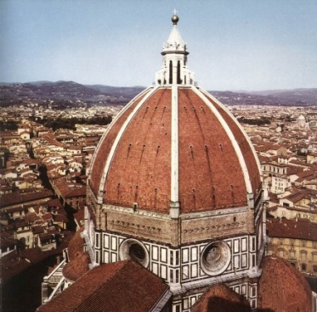
- How big is the dome?
- How was his work different than previous Gothic architecture?

- What is a cupola?

Additional Notes:

Lorenzo Ghiberti 1381-1455
What does the sacrifice of Isaac illustrate?
Why was Ghiberti’s chosen?
How many panels were there?
BRUNELLESCHI/ GHIBERTI– The Sacrifice of Isaac, competition plaques for the Baptistery Doors in Florence– 1401-02. --
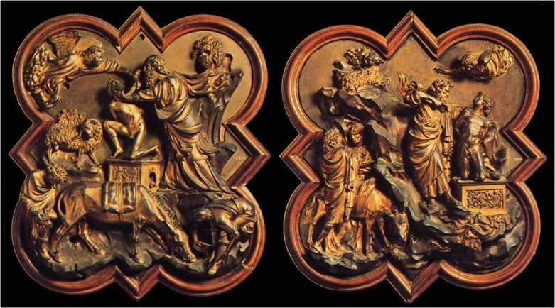

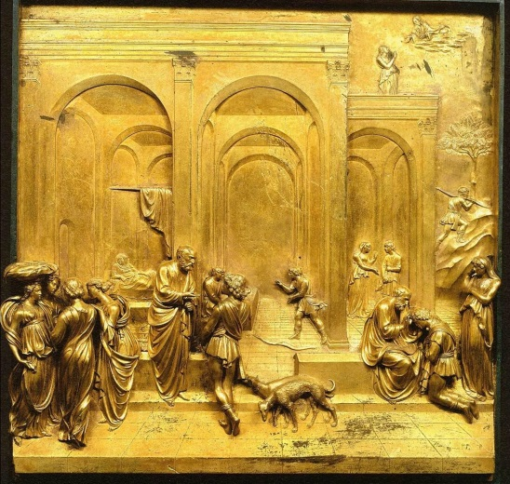
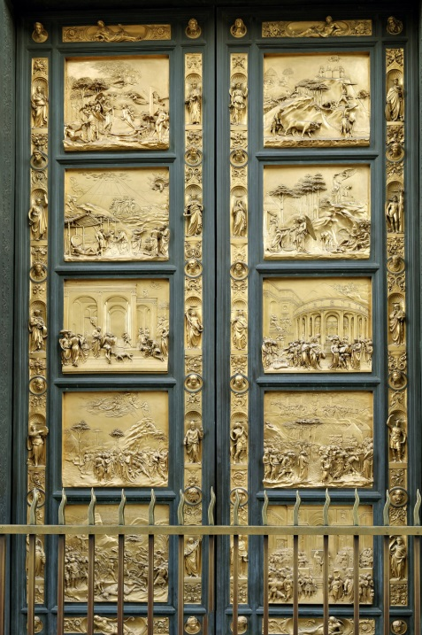
Gates of Paradise
1425-1452
- Where is it located?
- How many panels were there?
- What does the sacrifice of Isaac illustrate?
The Story of Jacob and Esau
1425-1452
From the Gates of Paradise

Donatello 1386-1466
- What was his work a combination of?

- What Rose did he mostly use in his sculptures and why?`

- What did the facial Expression did his statues provide?

- What did most of his statues look out over?

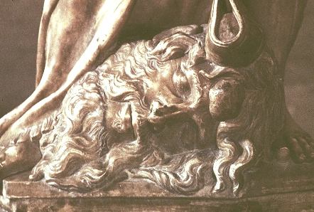
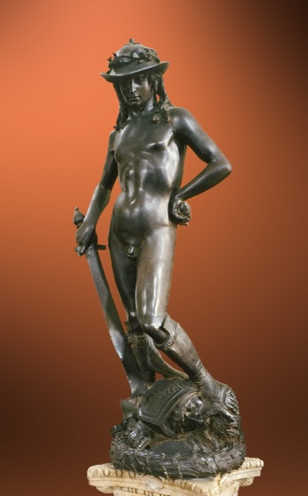
David 1430-1432
- Where is it located?
- What position is he standing in?
- What is the statue about?

- Why was David’s victory over Goliath symbolic?

- Why did the Florentines think it became symbolic?

Masaccio 1401-1428
- How did Masaccio revolutionize the art of painting?

- How old was he at the time?

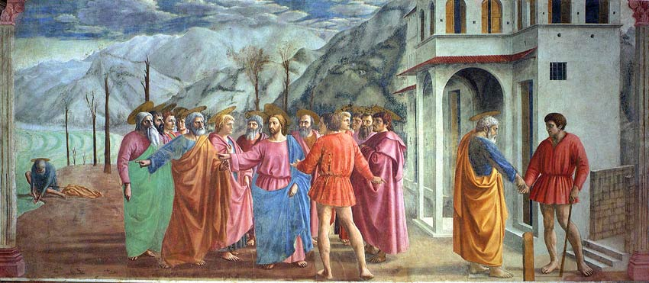
The Tribute Money 1427

- How does he use light in his paintings?

- What kind of perspective did he use to initiate Renaissance painting in Florence?

- What is the difference between Masaccio and Giotto’s depth?

- What kind of painting is it and where is it located?

- What is going on in the painting?

Fra Angelico 1400-1455
- Where was he born?
- What happened October 17, 1417?

- What monastery did he work at?
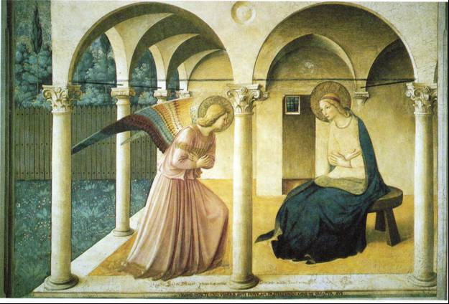
- What kind of art did he do at first?

Annunciation
1440-1450
- Who is the woman?

- What is the name of the small window with bars over it?

- What is happening in the picture?

Additional Notes:

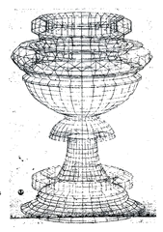
Paolo Uccello 1397-1475

- Where was he born?
- When and where did he die?
- What was he besides a painter?

- Who was he an apprentice to?
- Who was Lorenzo Ghiberti?

Battle of San Romano 1445
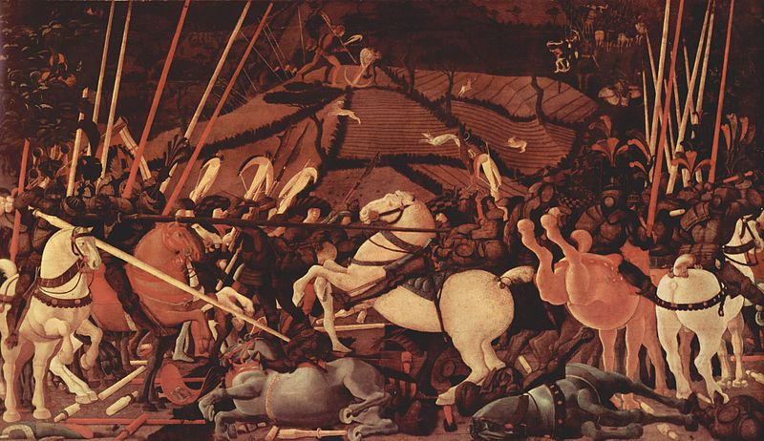
- Does this look real? Why or why not?

- What was this painting once a part of?

- What do you see?

- What is this painting about?

- What was such a great concern to him and his artwork? What was the result?

- Is there perspective in this painting?

Piero della Francesca 1420-1492

- How long did he study art?
- Where did he study?
- What is he well known for?

- Who were some of his teachers?
- How is he related to the artists of today?

- What was on flaw in his work?
The Discovering and Proving of the True Cross
1453-54
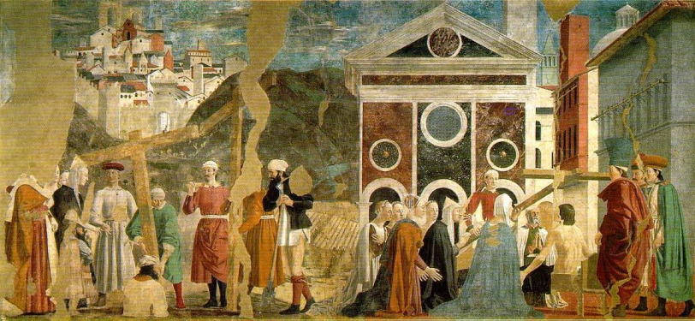
- What do you see?

- What is going on the painting?

- Where was this located?

- What is the name of the series of paintings this belongs to?

Sandro Botticelli 1445-1510
- Who was his teacher?
- Who was he a follower of?
- Who did he spend most of his life working for?
- Who are the Medici’s?
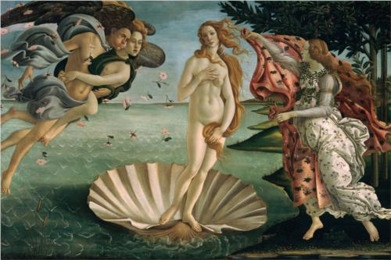

The Birth of Venus 1482
- Where was it located?

- What does it illustrate?

- What is it about?

- What makes it special?

Andrea Mantegna 1431-1506
- Who was he apprenticing to?
- Who was he influenced by?
- What techniques did he use in his artwork?

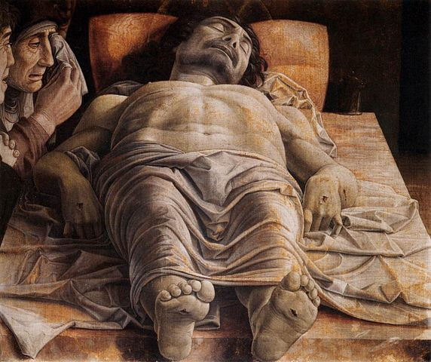
Dead Christ
1466
- Who is this man?

- What medium is this?

- What were the proportions of the painting?

- Where is this painting now?

Additional Notes:

Giovanni Bellini 1431-1516
- What did most of his family do?

- Who was he influenced by?

- What city did he live and work in?

The Doge Leonardo Loredan 1502
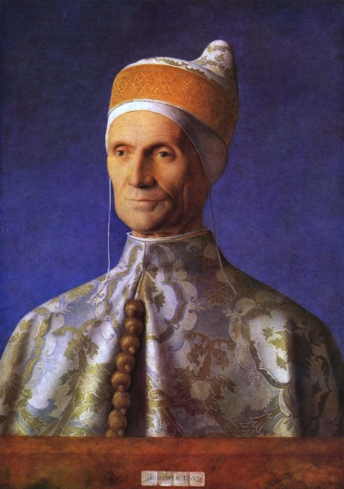
- Who is this a painting of?

- What is the medium?

- Locate the light source for this portrait.

- What characteristics in his paintings demonstrate the influence of Northern European painters?

