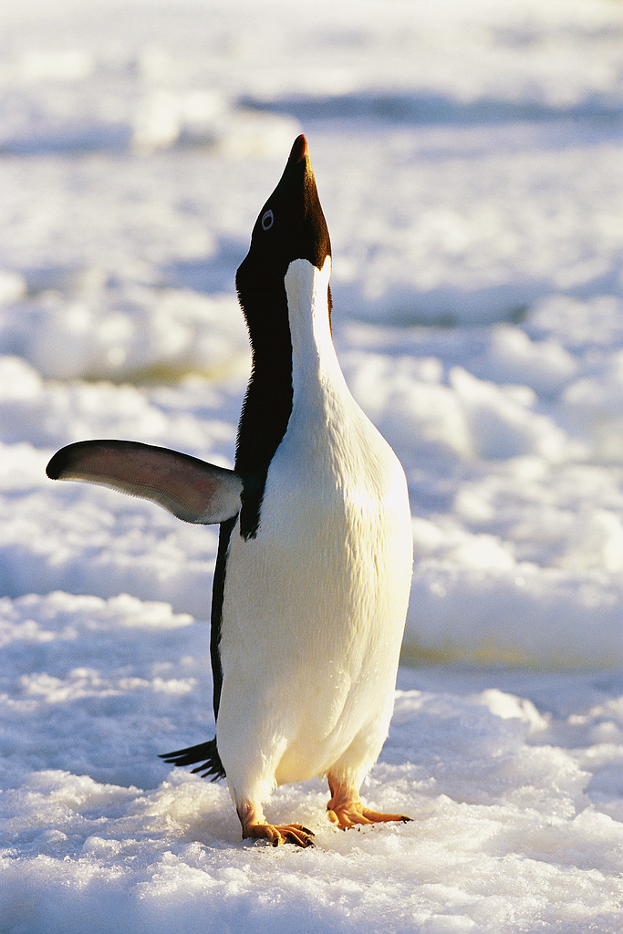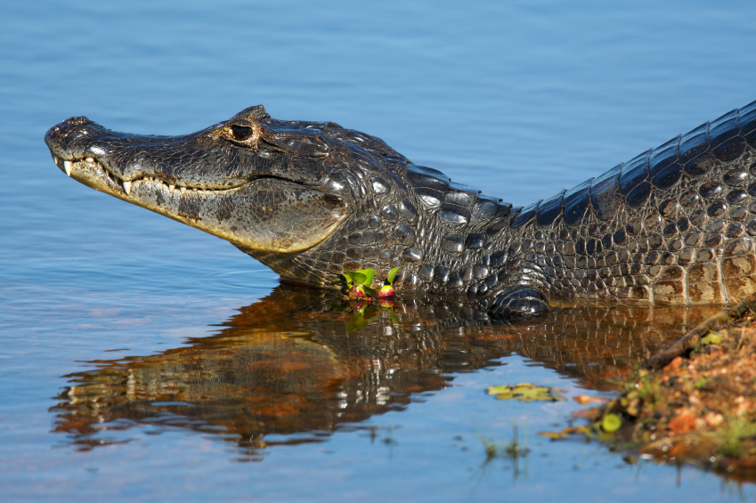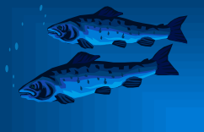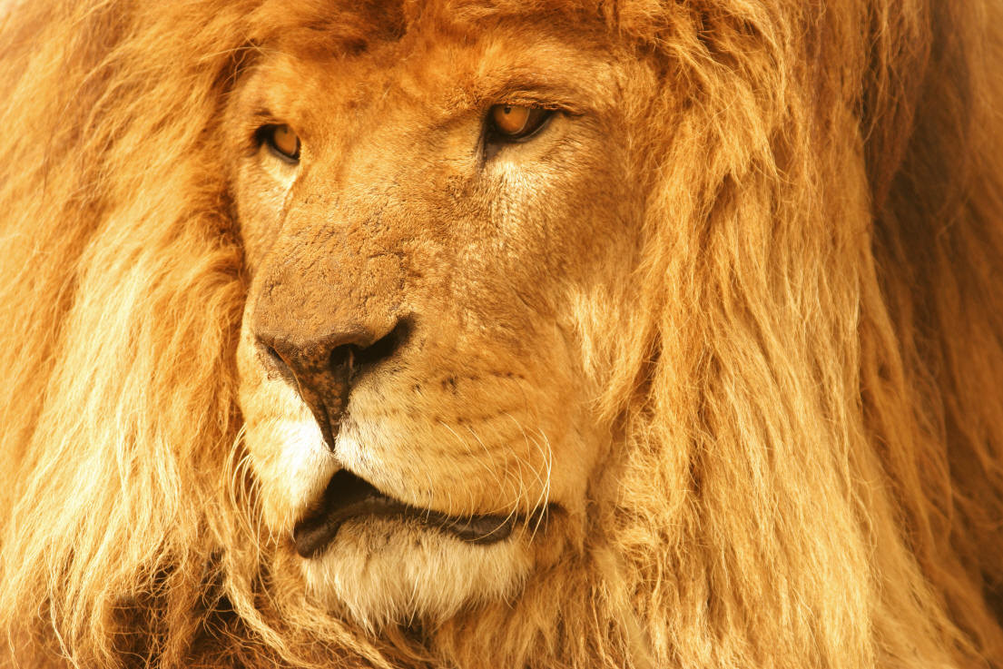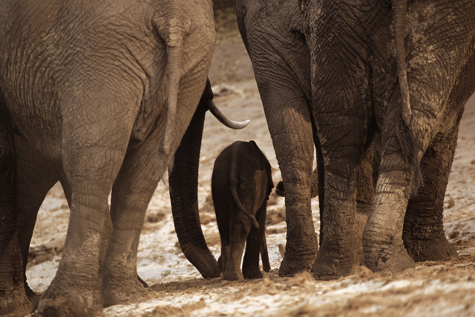

Animal Habitat Rubric

Student_______________________

Possible Student
Score: Score:

1. Following Directions 5 points _______

2. Authenticity 10 points _______
(design reflects research)

3. Well-Researched
Presentation 10 points _______

Total: 25 points _______

*Points will be deducted for late projects*

