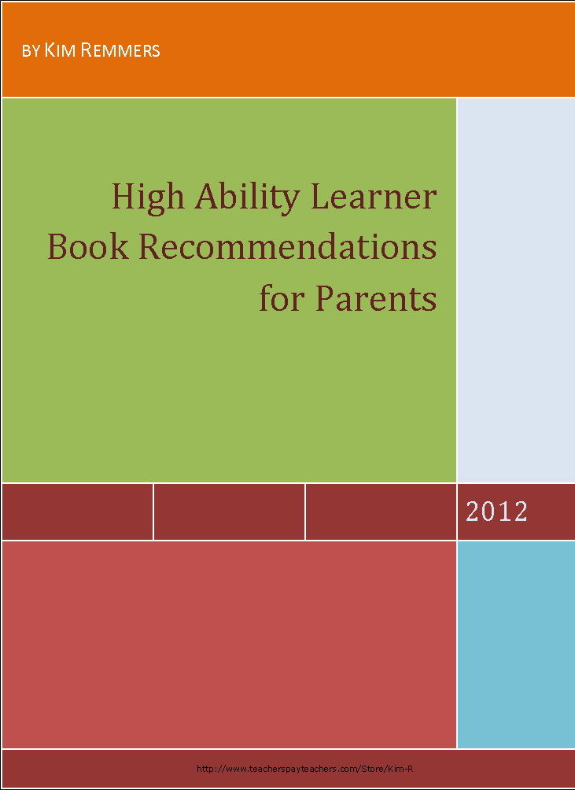
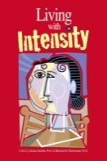
Author: Susan Daniels, Ph.D., Editor, Michael M. Piechowski, Ph.D., Editor
Publisher: Great Potential Press
ISBN: 978-0-910707-89-3
Pages: 260, paperback
Gifted children and adults are often misunderstood. Their excitement is viewed as excessive, their high energy as hyperactivity, their persistence as nagging, their imagination as not paying attention, their passion as being disruptive, their strong emotions and sensitivity as immaturity, their creativity and self-directedness as oppositional. This resource describes these overexcitabilities and strategies for dealing with children and adults who are experiencing them, and provides essential information about Dabrowski’s Theory of Positive Disintegration. Learn practical methods for nurturing sensitivity, intensity, perfectionism, and much more.
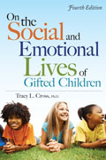
Author: Tracy L. Cross Ph.D.
Publisher: Prufrock Press
ISBN: 978-1-59363-498-8
Pages: 312, paperback, 2010
Raising happy, successful children is a goal of every parent of gifted children. In On the Social and Emotional Lives of Gifted Children, the nation's leading authority on the psychology of gifted children offers advice and encouragement for both parents and teachers. In a thoughtful, conversational style, the author offers an in-depth look at the complex social and emotional issues faced by gifted children. This revised and updated fourth edition of the popular text contains more than 10 new chapters, featuring contributions by scholars on gifted children's development from across the nation.
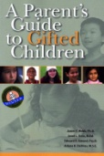
On the Social and Emotional Lives of Gifted Children tackles important and timely issues dealing with the social and emotional needs of today's gifted children, including who gifted children are and what giftedness means; how parents, teachers, and counselors can guide gifted children; the issues facing gifted students in the 21st century such as technology and terrorism; and how the education of gifted children can adapt for the future. This concise, sensitive look at gifted children and their social and emotional world offers unique insights for both teachers and parents who support these special children.
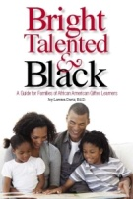
Author: J. Webb, J. Gore, E. Amend, & A. DeVries
Publisher: Great Potential Press/2007
ISBN: 0-910707-52-9
Raising a gifted child is both a joy and a challenge, yet parents of gifted children have few resources for reliable parenting information. The four authors, who have decades of professional experience with gifted children and their families, provide practical guidance in areas such as: Characteristics of gifted children; Peer relations; Sibling issues; Motivation & underachievement; Discipline issues; Intensity & stress; Depression & unhappiness; Educational planning; Parenting concerns; Finding professional help; and much, much more.
Author: Joy L. Davis, Ed. D.
Publisher: Great Potential Press, (paperback)
ISBN: 978-1-935067-02-3
Pages: 292
Being gifted and talented but also African American makes children double minorities, and the issues they face can be different from those faced by most other gifted children. This book provides helpful insights and guidelines for the parenting and education of Black gifted children. In addition to the challenges that are frequently experienced by many gifted children, such as underachievement and idealism, Black gifted children often must also deal with issues like discrimination and low expectations of them. Dr. Joy Davis offers practical information based on her personal experience as a parent and a gifted education professional. Several appendices in the back of the book provide useful resources for minority gifted students, as well as reading lists that will help empower these children and their parents. This book will help both African American parents and the educators who work with these bright, talented children.

Thank you for downloading this freebie.
The descriptions were found on amazon.com.
I used these on the Hawthorne HAL website found below. I rotate resources in and out about once a quarter. Feel free to let me know of resources you pass along to your students and parents. This page can be simply copied and sent out with gifted students.

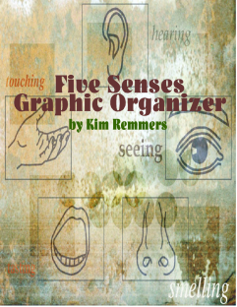 Check my TpT store for this freebie.

My Blog: differentiationdiving.blogspot.com/
TpT store: http://www.teacherspayteachers.com/Store/Kim-R
HAL website: http://hawthornehal.ha.hastingspublicschools.org/modules/groups/integrated_home.phtml?gid=2348769&sessionid=c538522813fe5ebc371058162965a3d3&t=53a7a0dfc2d379df1a2cf311fedff133

