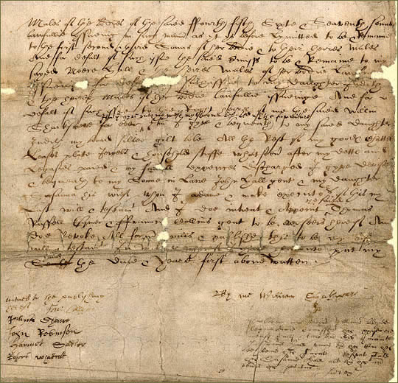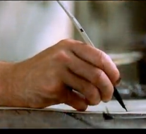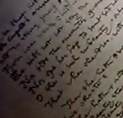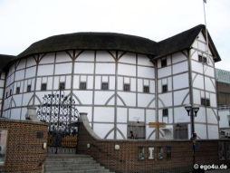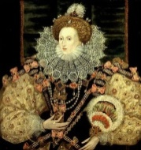C:\Dropbox\Teaching\Fake Twitter\tweets.gifC:\Dropbox\Teaching\Fake Twitter\bottombar.gif

**Christopher Marlowe** @ChrisMarlowe 1d

This writing gig…it’s like making a deal with the Devil  
#DrFaustus

* Favorited by William Shakespeare

**Lord Chamberlain’s Men** @lordCmen 1d

Come down to #theglobe tonight for our final performance of Titus Andronicus

* Retweeted by William Shakespeare

Based on a template from Choose Awesome http://ichooseawesome.wordpress.com

theplague

Dark Lady

theglobe

Lord Chamberlain

Stratford upon Avon

bards

Sir Walter Raleigh

Spanish Armada

amwriting

Virgin Queen

**William Shakespeare** @willyshakes 1w

Research, research, research…can you poison someone in the ear? #plotpoint #amwriting

Expand

**William Shakespeare** @willyshakes 1w

Lord, what fools these playwrights be!

Expand

**James Burbage** @TheBurbs

Followed by Blackfriars and others

Follow

**Queen Elizabeth I** @QueenLizOne

Followed by TheSheriff and others

Follow

**William Shakespeare** @willyshakes 20m

@ChrisMarlowe What would you know!?!?!? #idiot

**William Shakespeare** @willyshakes 20m

@MrsShakespeare I miss you too…not!

**William Shakespeare** @willyshakes 15m

Oh the darling buds of May! #teaser

Expand

**William Shakespeare** @willyshakes 3m

@QueenLizOne I hope you’ll like my latest work

@willyshakes

**William Shakespeare**

**3,445,234**

**5,321**

**14,234**

**William Shakespeare**

**@willyshakes**

Writes the occasional story and poem

London, UK – http://www.thebard.com

C:\Dropbox\Teaching\Fake Twitter\tweets.gif

**Lord Chamberlain’s Men** @lordCmen 1d

Come down to #theglobe tonight for our final performance of Titus Andronicus

* Retweeted by William Shakespeare

**William Shakespeare** @willyshakes 20m

@MrsShakespeare I miss you too…not!

**William Shakespeare** @willyshakes 20m

@ChrisMarlowe What would you know!?!?!? #idiot

**William Shakespeare** @willyshakes 3m

@QueenLizOne I hope you’ll like my latest work

**William Shakespeare** @willyshakes 15m

Oh the darling buds of May! #teaser

Expand

**Christopher Marlowe** @ChrisMarlowe 1d

This writing gig…it’s like making a deal with the Devil  
#DrFaustus

* Favorited by William Shakespeare

**Christopher Marlowe** @ChrisMarlowe 1d

This writing gig…it’s like making a deal with the Devil  
#DrFaustus

* Favorited by William Shakespeare

**Lord Chamberlain’s Men** @lordCmen 1d

Come down to #theglobe tonight for our final performance of Titus Andronicus

* Retweeted by William Shakespeare

Based on a template from Choose Awesome http://ichooseawesome.wordpress.com

**William Shakespeare** @willyshakes 1w

Research, research, research…can you poison someone in the ear? #plotpoint #amwriting

Expand

**William Shakespeare** @willyshakes 1w

Lord, what fools these playwrights be!

Expand

**William Shakespeare** @willyshakes 20m

@ChrisMarlowe What would you know!?!?!? #idiot

**William Shakespeare** @willyshakes 20m

@MrsShakespeare I miss you too…not!